Code Build:

Follow the tutorial from below link to create source code

<https://docs.aws.amazon.com/codebuild/latest/userguide/getting-started-cli.html>

Create 2 s3 buckets one for input and other for output

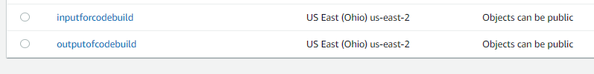

Upload the source code into input bucket

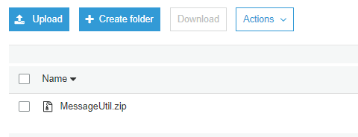

Go to code build option in aws console and click on Create Build Project

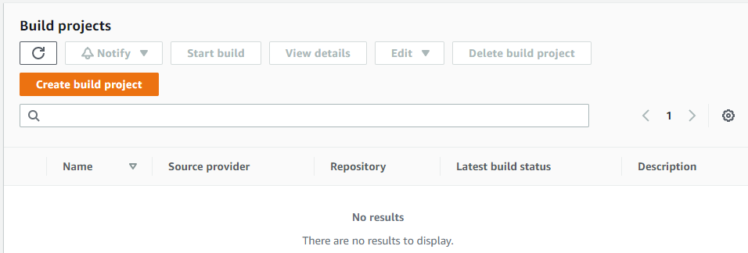

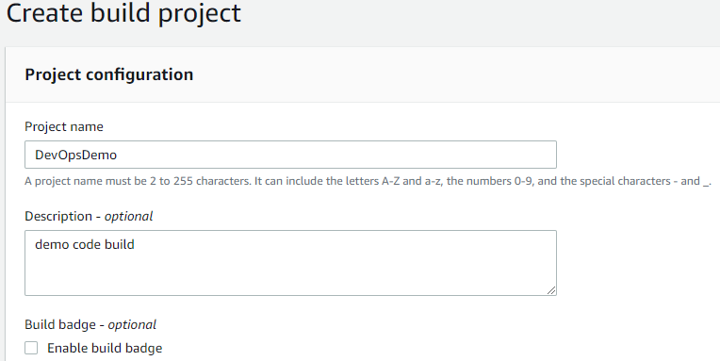

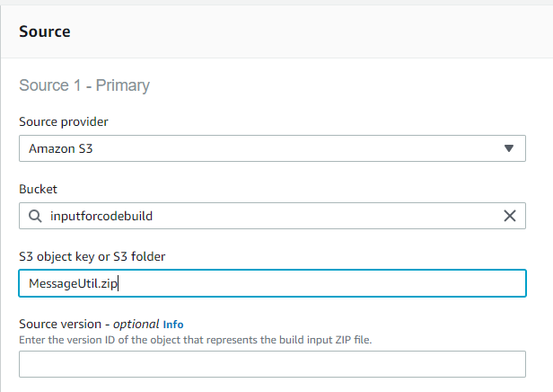

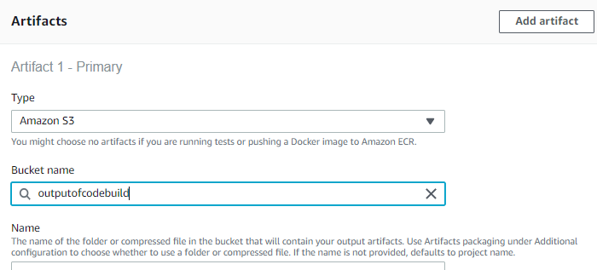

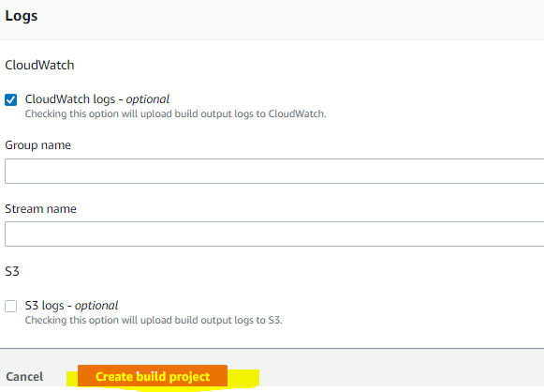

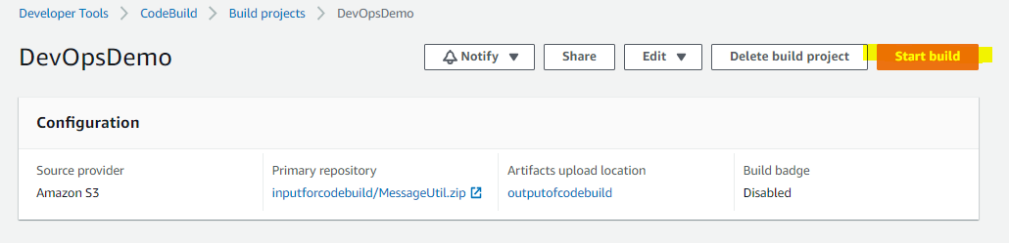

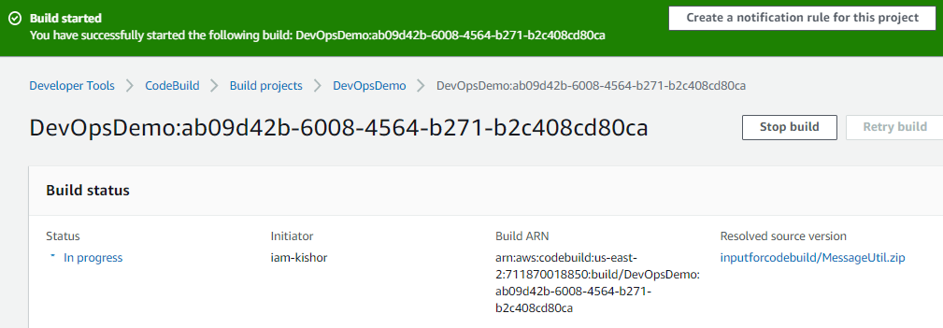

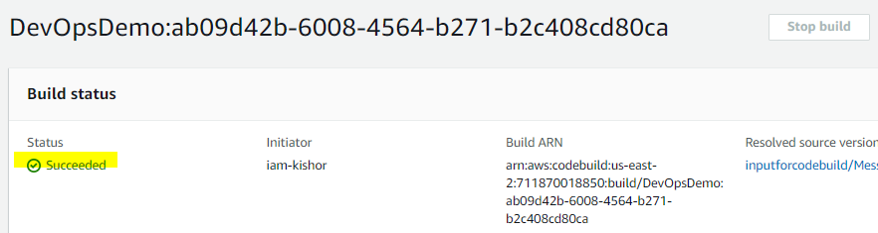

Build artifact I.e jar file is uploaded into output bucket

